This is the command how to join rdp
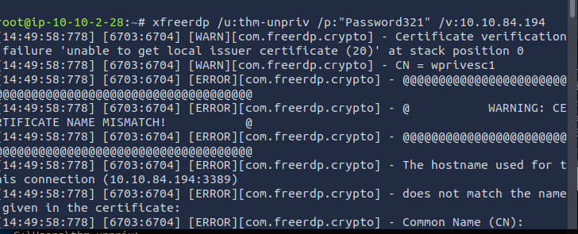
Windows Privilege Escalation

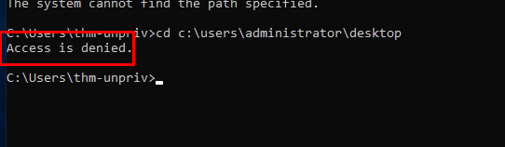
Harvesting Passwords from Usual S
Credential Harvesting from PowerShell History

The task mentioned how to access Powershell log history, so let’s do that
Any command that was running in the power shall history are below

C:\Users\thm-unpriv>type %userprofile%\AppData\Roaming\Microsoft\Windows\PowerShell\PSReadline\ConsoleHost_history.txt
...
cmdkey /add:thmdc.local /user:julia.jones /pass: ZuperCkretPa5z

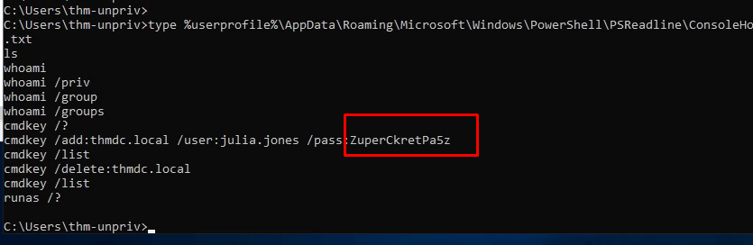
We have to path to search as you can see in the first location nothing is her
Finding Credentials in Configuration Files
Applications often store connection strings, which include usernames and passwords, in configuration files like web.config. These files can sometimes be read by unprivileged users

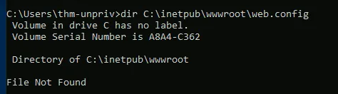
In the second location as you can see the password is in the pic below
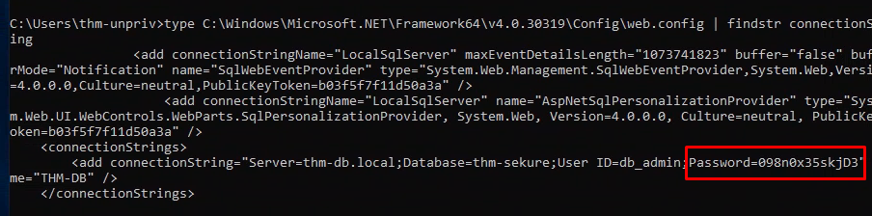

Abusing Stored CMD Credentials

The Windows cmdkey command allows users to store credentials for later use. An attacker can list these stored credentials and potentially use them.

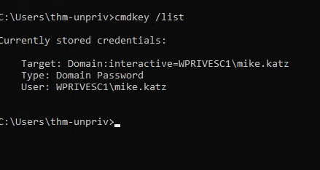

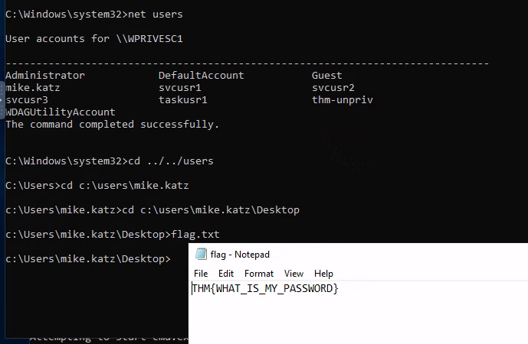
4. Harvesting Passwords from the Registry (PuTTY)
Applications like PuTTY often store proxy and session configurations, including passwords, in the Windows Registry. These can be queried by the user who saved them.
AS you can see The PuTTY proxy password CoolPass2021 was extracted from the registry.
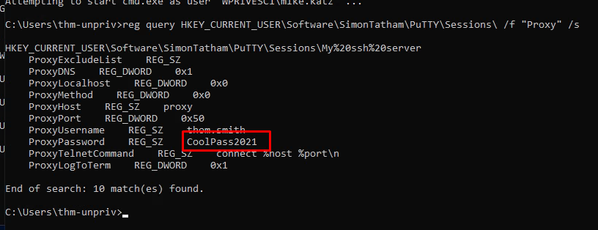

5. Abusing Vulnerable Scheduled Tasks
Explanation:
If a scheduled task runs with elevated privileges and the user can modify the script or batch file that the task executes, the user can replace that script with a malicious payload (like a reverse shell) to gain elevated access.
Evidence from Lab:
The task vulntask was found to run as SYSTEM.
The user had write permissions to the script C:\tasks\schtask.bat.
The script was replaced with a command to send a reverse shell.

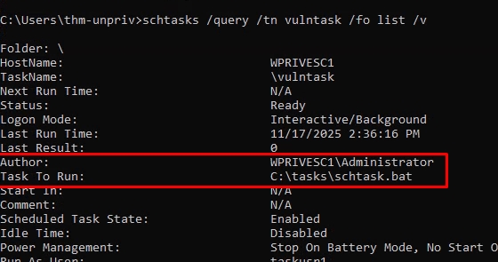
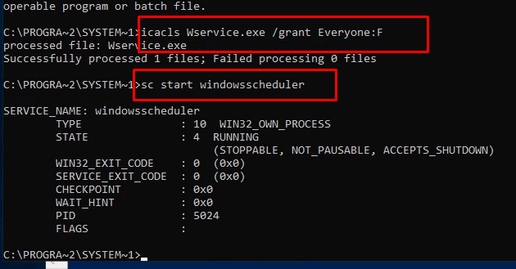

6. Abusing Service Misconfigurations

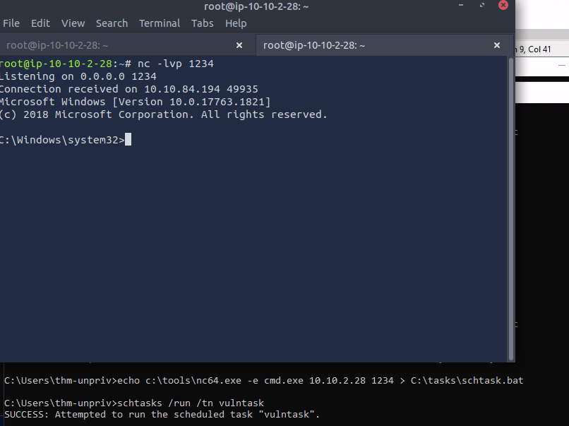

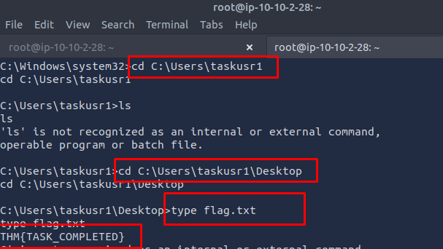

Abusing Service Misconfigurations

Everyone (M) means that all users can modify this. This is dangerous, and is unlikely to be the case ‘in the wild’.
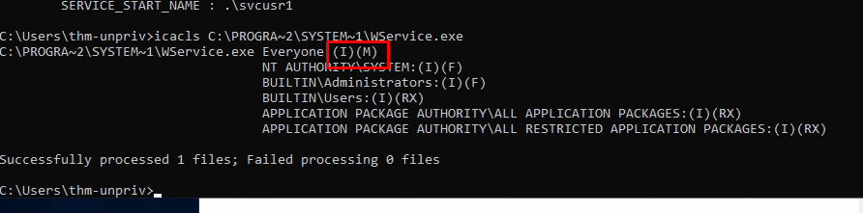

THE LESSNER IS RESIVED
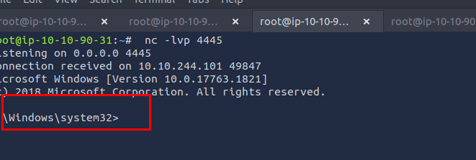

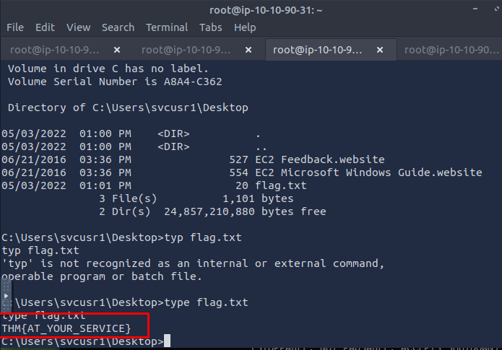

Service 2
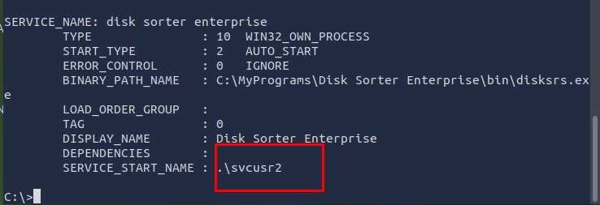

C:\Users\thm-unpriv>icacls C:\MyPrograms\Disk.exe /grant Everyone:F

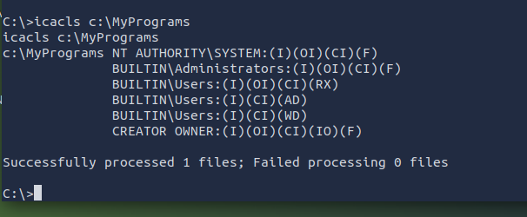

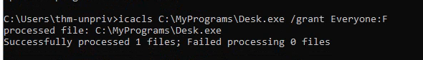

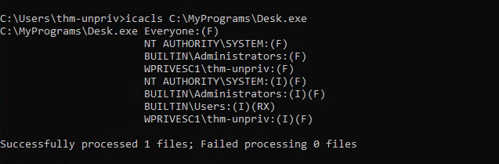

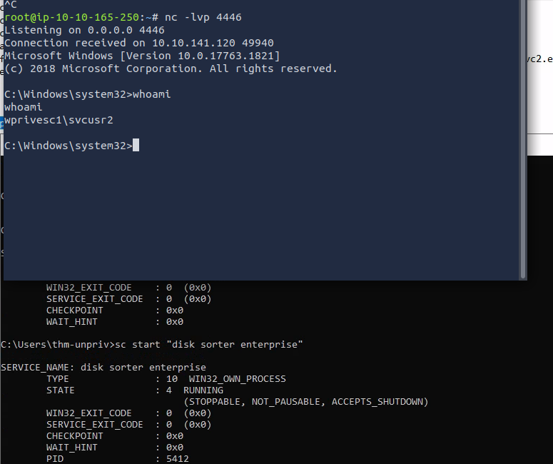

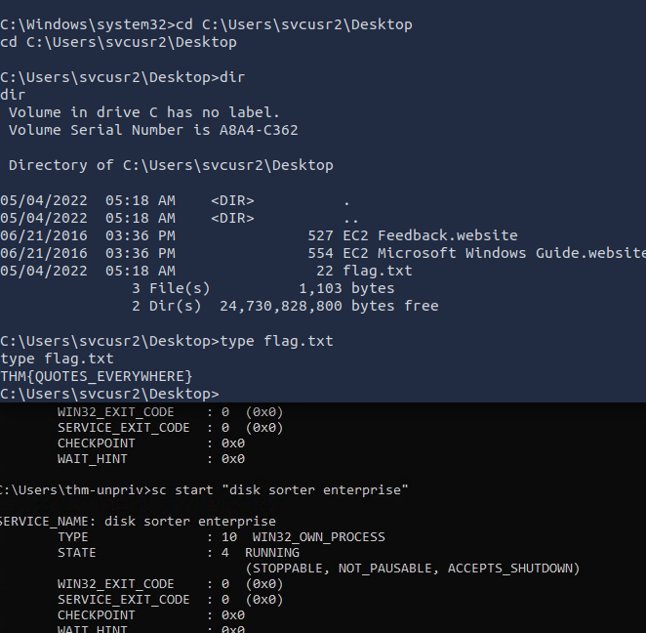

Any user can reconfigure this service
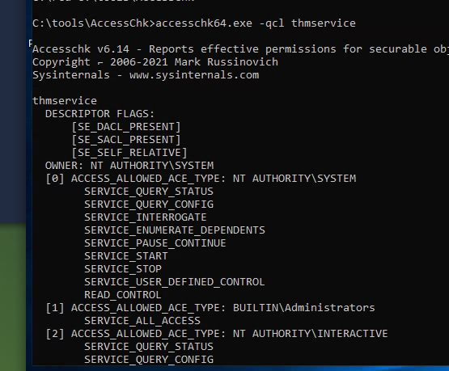

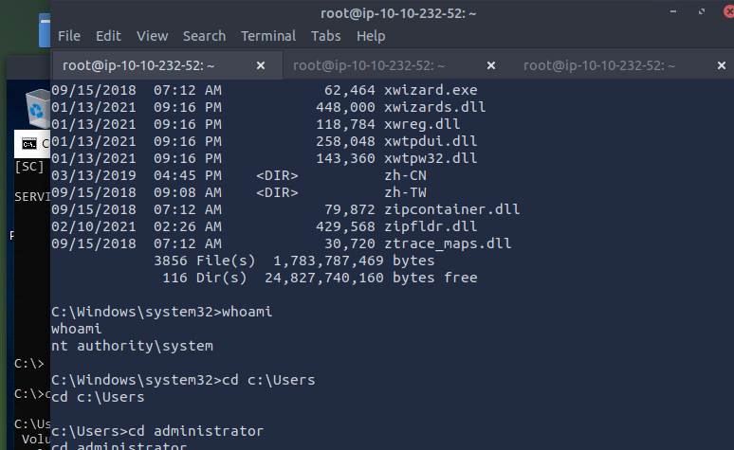

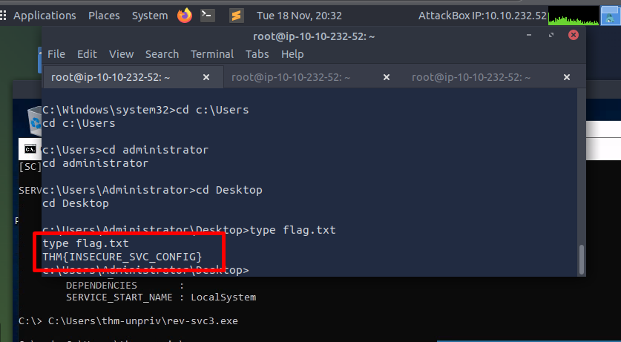

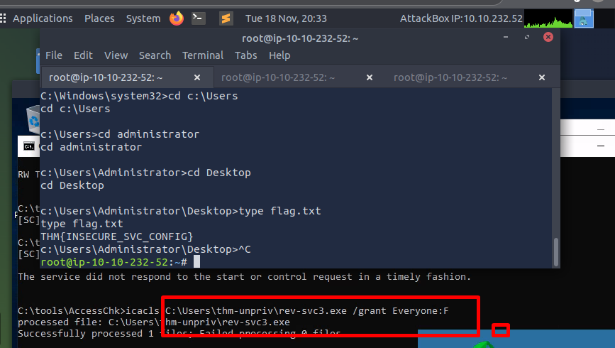

Abusing dangerous privileges
SeBackup/SeRestore
first, I opened an RDP through the AttackBox.
The task now asks us to backup the SAM & SYSTEM hashes. To make it clear, these hashes contain accoutn information. Getting this information will give us account names and password.
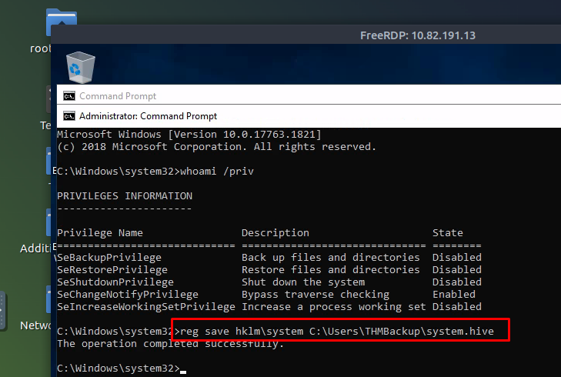
Now we need to share these files onto our attacking machine. THM suggest an SMB server. I’ve not done this before, so let’s give it a go.
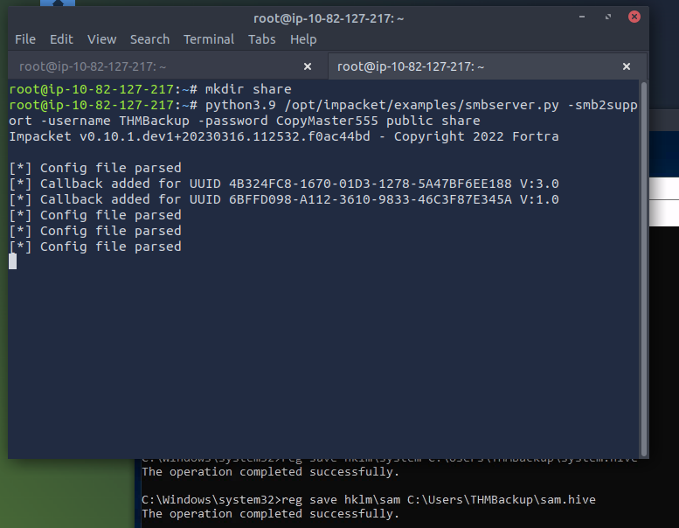
A reverse shell connection was received with high privileges, allowing access to taskusr1's desktop and the flag THM[TASK_COMPLETED]

If a Windows service runs under a high-privilege account (like SYSTEM) but the service executable file (.exe) has weak permissions (e.g., Everyone has Modify rights), a low-privilege user can replace the legitimate .exe with a malicious one. When the service is restarted, the malicious code runs with elevated privileges

The user replaced Disk.exe, started the "Disk Sorter Enterprise" service, and received a reverse shell as svcusr2, leading to the flag THM[QUOTES_EVERYWHERE].

The user replaced WService.exe with a malicious payload and started the service, gaining a reverse shell as svcusr1 and the flag THM[AT_YOUR_SERVICE].
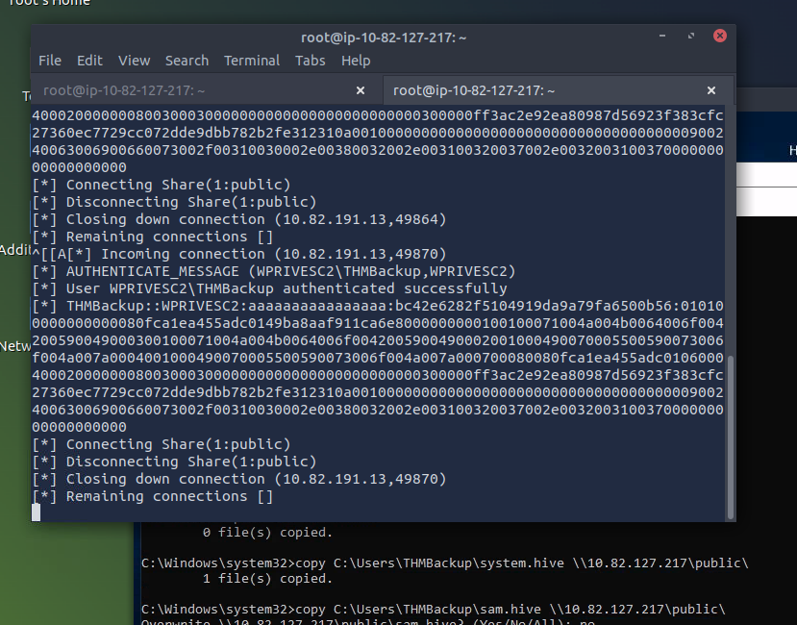
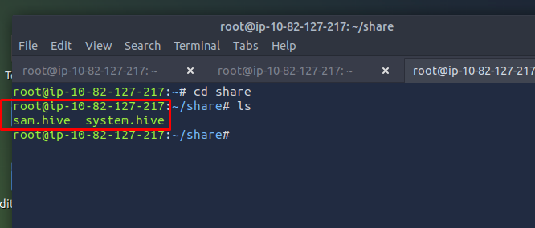

The user replaced Disk.exe, started the "Disk Sorter Enterprise" service

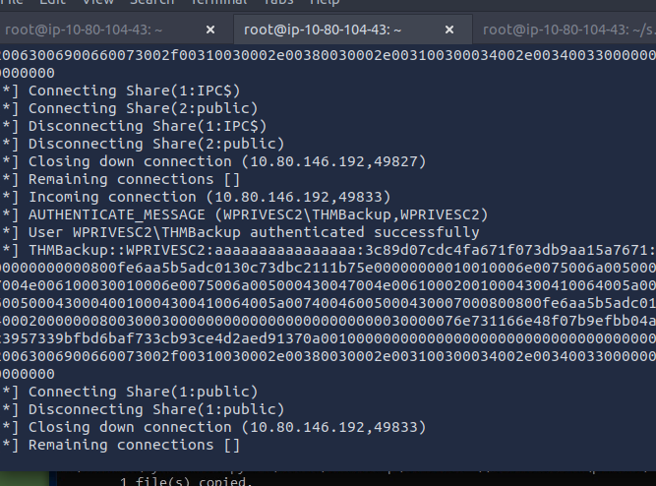
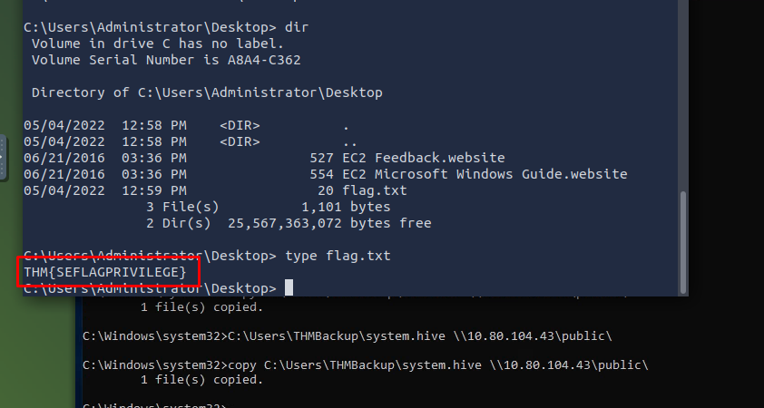

Abusing vulnerable software
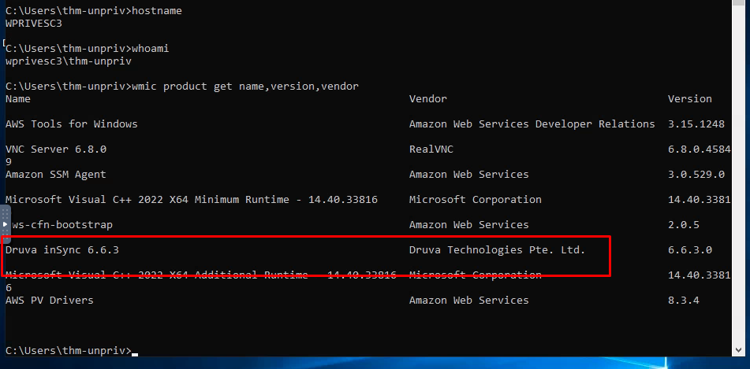
The software "Druva inSync" 6.6.3 was installed, which was known to be vulnerable to DLL Hijacking.
A malicious DLL was placed in a writable location that the application would search.
When the application was run (e.g., via rcsd.exe), it loaded the malicious DLL.
This triggered a User Account Control (UAC) prompt. Since the user pwnd was already a member of the Administrators group, they could approve the UAC prompt, allowing the malicious code to run with full administrator privileges.

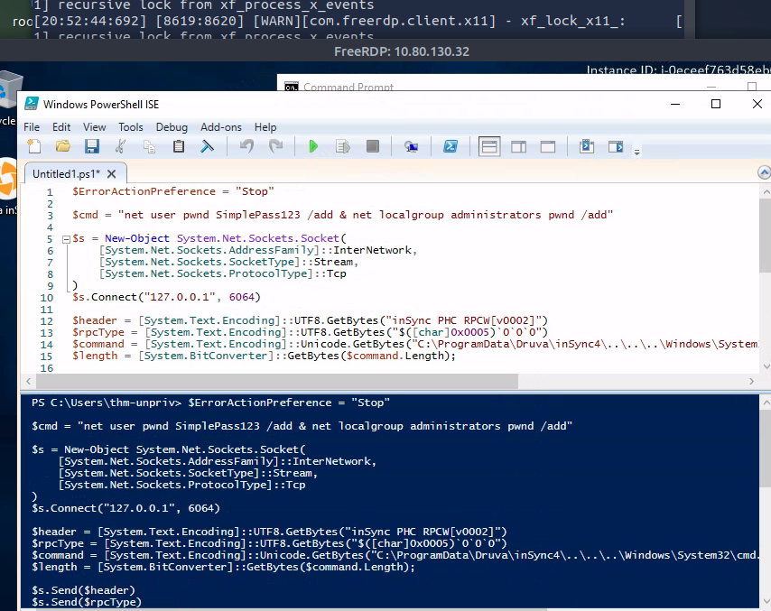

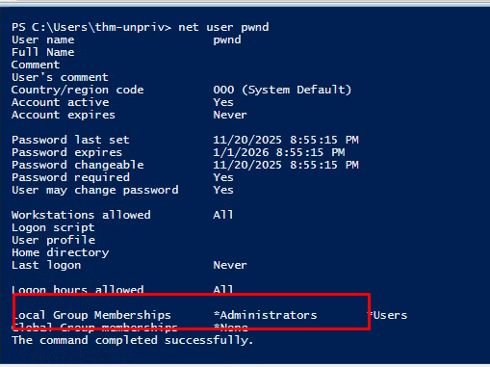
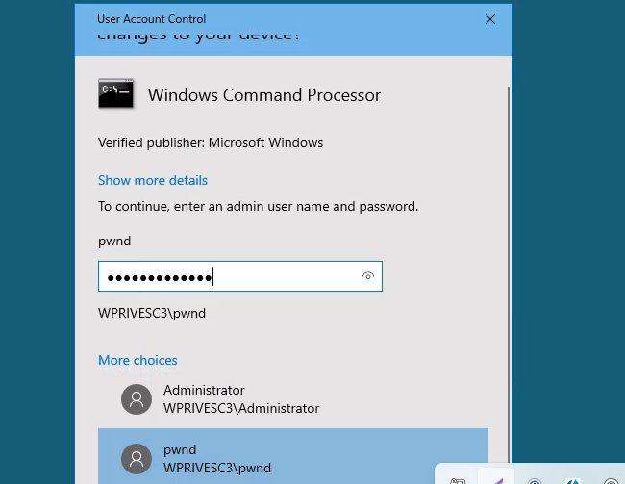
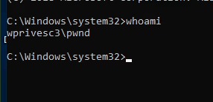
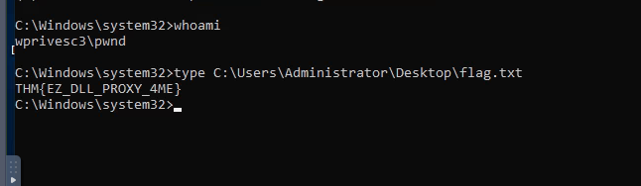

Linux enormatiopn
Sach as
